A L e v e l P h y s i c s

Student Handbook
2015/16

Welcome to A Level Physics at Beechen Cliff School. This popular subject is taught with four hours of lessons per week, split between two teachers.
This academic, mathematical, practical and engaging course builds upon GCSE work in Year 12 with Mechanics, Electricity and an introduction to Quantum Effects. Year 13 students study Thermodynamics, Medical Applications, Particle Physics and Cosmology as part of the OCR Specification A course.
Mr L Matheson
Head of Physics

The Physics Department
Physics is taught by a number of specialists at Beechen Cliff in very well equipped facilities with all the major items of practical equipment used to demonstrate key concepts and allow students to carry out practical work in small groups.
Mr L Matheson – Head of Physics/ Science GCSE Coordinator
Studied for a Master in Mechanical Engineering. With experience in industry working for a multi-national engineering consultancy, he also served in the Royal Artillery before becoming as a teacher.
Mr A Seal – Head of Science Faculty
Masters of Geophysics, with experience of the oil and commodities industry who has taught physics across a range of courses at GCSE and A Level. He is also the Head of Faculty with responsibility for running the whole department.
Mr P Watts – Deputy Head of Beechen Cliff
With a degree in Physics and Music he then completed his Masters in Radiation and Environmental Protection at The University of Cardiff. As well as teaching Physics he is also the Deputy Head of Beechen Cliff School.
Mr O Abbott – Teacher of Physics/ KS3 Coordinator
An experienced teacher who started his career with a degree in Physics from The University of Cardiff. He is a keen rugby player and cricketer who is also responsible for students in the Beechen Cliff boarding facility.
Mrs J Lamb – Senior Science Technician
Mrs Lamb leads an outstanding team of science technicians. She brings a wealth of experience from her time in industry and previous schools. She worked at Mullards on infrared optical devices and also has a patent in her name.
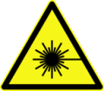
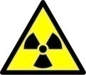

LAB SAFETY
Please do not enter science laboratories unsupervised. Many hazards are not obvious to those unfamiliar with these areas.
In the event of a fire alarm please make your way to the designated area on the top playing fields using the nearest fire exit.

Year 12 Resources
This is the first year that the new specification course is taught to Year 12. The content is largely the same, although the method of assessment has changed.
All students will sit the AS exam at the end of year 12 with those who are successful continuing to study the course into Year 13. There will be assessed practicals throughout the year that make up the Practical Endorsement awarded at the end of the A Level course.

Year 12 Modules
Module 1 – Development of practical skills in physics
- 1.1 Practical skills assessed in a written examination
- 1.2 Practical skills assessed in the practical endorsement
Module 2 – Foundations of physics
- 2.1 Physical quantities and units
- 2.2 Making measurements and analysing data
- 2.3 Nature of quantities
Module 3 – Forces and motion
- 3.1 Motion
- 3.2 Forces in action
- 3.3 Work, energy and power
- 3.4 Materials
- 3.5 Momentum
Module 4 – Electrons, waves and photons
- 4.1 Charge and current
- 4.2 Energy, power and resistance
- 4.3 Electrical circuits
- 4.4 Waves
- 4.5 Quantum physics

Year 13 Modules
Module 5 – Newtonian world and astrophysics
- 5.1 Thermal physics
- 5.2 Circular motion
- 5.3 Oscillations
- 5.4 Gravitational fields
- 5.5 Astrophysics and cosmology
Module 6 – Particles and medical physics
- 6.1 Capacitors
- 6.2 Electric fields
- 6.3 Electromagnetism
- 6.4 Nuclear and particle physics
- 6.5 Medical imaging
Assessments
AS Level
- Breadth in Physics 70 marks 1 hour 30 minutes Modules 1, 2, 3 and 4
- Depth in Physics 70 marks 1 hour 30 minutes Modules 1, 2, 3 and 4
A Level
- Modelling Physics 100 marks 2 hours 15 minutes Modules 1, 2, 3 and 5
- Exploring Physics 100 marks 2 hours 15 minutes Modules 1, 2, 4 and 6
- Unified Physics 70 marks 1 hour 30 minutes Modules 1, 2, 3, 4, 5 and 6
- Practical Endorsement in Physics Pass or Fail
Practical Assessment Group Tasks
These tasks will be carried out during Year 12.
PA 1.2 | Investigating Terminal Velocity
PA 2.1 | Determining the Young’s Modulus of a Metal
PA 3.2 | Investigating the Electrical Characteristics of Non-Ohmic Components
PA 4.1 | Investigating Resistance
PA 5.1 | Determining the Wavelength of Light with a Diffraction Grating
PA 5.3 | Determining Frequency and Amplitude using an Oscilloscope
PA 6.1 | Determining the Planck Constant

Module 1, 2 and 3 |  | Module 1 and 4
L6A – Mr Abbott  L6B – Mr Seal  L6C – Mr Matheson  L6F – Mr Abbott |  | L6A – Mr Watts  L6B – Mr Watts  L6C – Mr Seal  L6F – Mr Matheson
Module 1, 2 and 3 | Term | Module 1 and 4
- 2.1 Physical quantities and units  - 2.2 Making measurements and analysing data  - 2.3 Nature of quantities  - 1.2 Practical skills assessed in the practical endorsement | 1 | - 4.1 Charge and current  - 1.2 Practical skills assessed in the practical endorsement  - 4.2 Energy, power and resistance  - PA 3.2
Half Term
- 3.1 Motion  - 3.2 Forces in action  - PA 1.2 | 2 | - 4.3 Electrical circuits  - PA 4.1
Christmas
- 3.3 Work, energy and power | 3 | - 4.4 Waves  - PA 5.1  - PA 5.3
Half Term
- 3.4 Materials  - PA 2.1  - 3.5 Momentum | 4 | - 4.5 Quantum physics  - PA 6.1
Easter
- Revision and Exam Skills | 5 | - Revision and Exam Skills
Half Term
- 5.5 Astrophysics and cosmology | 6 | - 5.5 Astrophysics and cosmology
Summer

Year 13 Course Structure and Resources
Year 13 students continue to study OCR Physics A – H158, H558 which is also known as OCR Specification A. This is split into a number of modules, G481 to G486.
G481
G483
G482
G484
G486
G485

A2 Level – Year 13
Unit Title | Description of Content | Assessment Method and Weighting
G484 | G484: The Newtonian World  - Newton’s laws and momentum  - Circular motion and oscillations  - Thermal Physics | 1 hour 15 minute written exam  A Level – 15%
G485 | G485: Fields, Particles and Frontiers of Physics  - Electric and magnetic fields  - Capacitors and exponential decay  - Nuclear physics  - Medical imaging  - Modelling the universe | 2 hour written exam  A Level – 25%
G486 | G486: Practical Skills in Physics 2  - Qualitative  - Quantitative  - Evaluative | Internal assessment  A Level – 10%

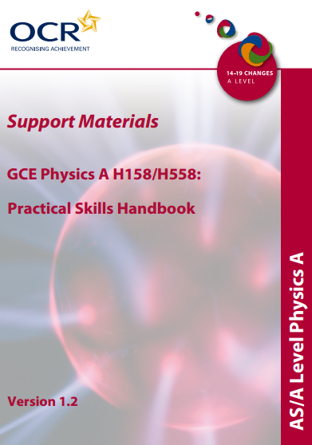
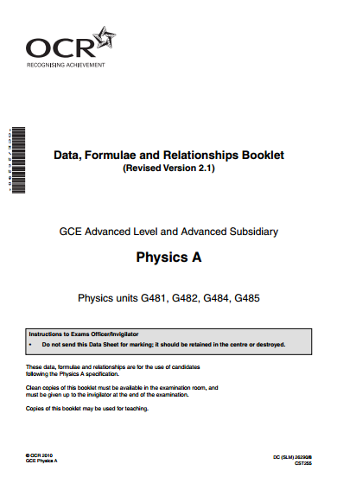
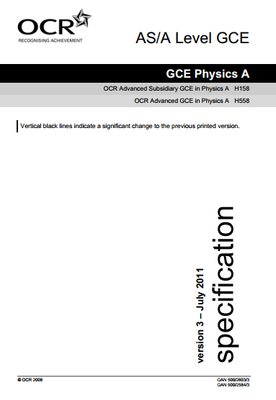
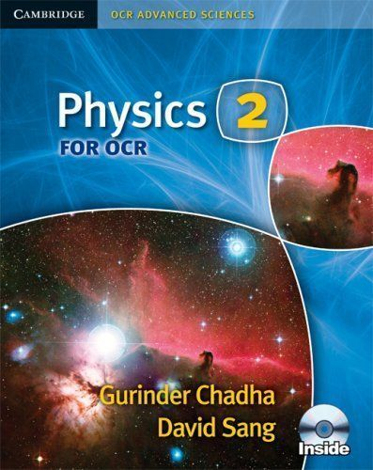

The OCR Website contain a wealth of information for students and parents; including the most up-to-date information for exam dates, alterations to the course content and answers to commonly asked questions.
Data, Formulae and Relationships Booklet (Revised Version 2.1)
This essential booklet contains all the equation and physical constants you will need throughout the course, a copy will be issued to all students for use throughout the course.
Full Course Specification (May 2013)
This weighty document outlines the entire course content, assessment information and technical information for teachers and technicians. Chapter 3 is essential reading in preparation for the exams.
Practical Skills Handbook (Version 1.2)
20% of the course is assessed with practical work carried out in class. For the best chance of success in modules G483 and G486 Chapter 10 of the Practical Skills Handbook must be studied.
Past Papers and Mark Schemes are an essential tool for revision and preparation for this course. They can all be found on the Beechen Cliff website.
The core textbook that every student must purchase for the AS course is ‘Physics 2 for OCR’ from Cambridge University Press, this must be brought to every lesson. These can often be found for a reasonable price on Amazon or can be bought direct from the publishers. It includes an interactive CD-ROM that has extra help and hints linked to the chapter and past exam questions.
Teaching Schedule
Please note the sequence of modules taught will not change, however, there may be slight alterations to the dates and end of unit assessments.
U6B – Mr Abbott  U6C – Mr Matheson  U6E&F – Mr Seal | Group Splits |  | U6B – Mr Matheson  U6C – Mr Seal  U6E&F – Mr Watts
G484 and G486 | School Week |  | G485
4.1.1 Newton's laws of motion 4.1.2 Collisions  End of Unit Assessment  4.2.1 Circular motion  4.2.2 Gravitational fields  4.2.3 Simple harmonic motion  End of Unit Assessment | Week 1 | Term 1 | 5.1.1 Electric fields 5.1.2 Magnetic fields  5.1.3 Electromagnetism  End of Unit Assessment
 | Week 2
 | Week 3
 | Week 4
 | Week 5
 | Week 6
 | Week 7
 | Week 8
Half Term
G486 Qualitative Task | Week 9 | Term 2 | 5.2.1 Capacitors  End of Unit Assessment
 | Week 10
G486 Quantitative Task | Week 11
 | Week 12 |  | 5.3.1 The nuclear atom  5.3.2 Fundamental particles
G486 Evaluative Task | Week 13
 | Week 14
 | Week 15
Christmas Holiday
JANUARY MOCK EXAM  G486 Resits | Week 16 | Term 3 | JANUARY MOCK EXAM
 | Week 17
 | Week 18 |  | 5.3.3 Radioactivity  5.3.4 Nuclear fission and fusion  End of Unit Assessment 5.4.1 X-Rays
 | Week 19
 | Week 20
 | Week 21
Half Term

U6B – Mr Abbott  U6C – Mr Matheson  U6E&F – Mr Seal | Group Splits |  | U6B – Mr Matheson  U6C – Mr Seal  U6E&F – Mr Watts
G484 and G486 | School Week |  | G485
4.3.1 Solid, liquid and gas 4.3.2 Temperature  4.3.3 Thermal properties  4.3.4 Ideal Gases  End of Unit Assessment | Week 22 | Term 4 | 5.4.2 Diagnostic methods  5.4.3 Ultra Sound  End of Unit Assessment
 | Week 23
 | Week 24
 | Week 25 |  | 5.5.1 Structure of the Universe 5.5.2 The evolution of the Universe  End of Unit Assessment
 | Week 26
 | Week 27
Easter Holidays
Revision | Week 28 | Term 5 | Revision
 | Week 29
 | Week 30
 | Week 31
 | Week 32
Half Term
Study Leave | Week 33 | T 6 | Study Leave
 | Week 34
 | Week 35
The rest of your life

Examinations
The course is assessed through a combination of external exams and internally marked assessments.
There is the opportunity to re-sit each module with the highest mark for each module carried forward. Dates for the external exams will be publishes nearer the time, although can often be found on the OCR website.
G483 and G486 are internally assessed practical units. Focusing on Qualitative, Quantitative and Evaluative skills these are carried out during lesson periods. There are a total of three papers for each area with the highest mark carried forward to the final result.
Once the exams have been marked the papers are moderated to ensure that marking is consistent by all markers.
The raw mark is converted to a Uniform Mark Score, UMS, that allows for the weighting of each module with the highest possible score totalling 300 for AS and 600 for the full A Level. For example, G485 is worth 25% of the overall total so the module has a mark out of 150. The papers are graded so grades awarded each year are equivalent.
 |  | AS Level | A Level
Grade | Percentage | Mark /300 | Mark /600
A* | See note below
A | 80 | 240 | 480
B | 70 | 210 | 420
C | 60 | 180 | 360
D | 50 | 150 | 300
E | 40 | 120 | 240
U | <40 | <120 | <240

To distinguish between the highest achievers the A* was recently introduced for those taking the full A Level. Candidates achieving at least 480 uniform marks in their Advanced GCE, i.e. grade A, and who also gain at least 270 uniform marks in their three A2 units will receive an A* grade.

Online Resources
There is a huge amount of material available on the internet. All students should become part of the A Level Physics Facebook group. This is a closed secret group that allows you to see and post messages about the course at Beechen Cliff.

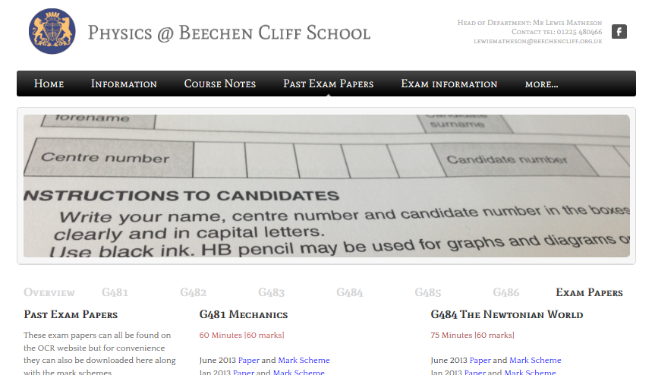
The Beechen Cliff Physics website has a huge amount of information, including course notes, every past paper and documents you may need.
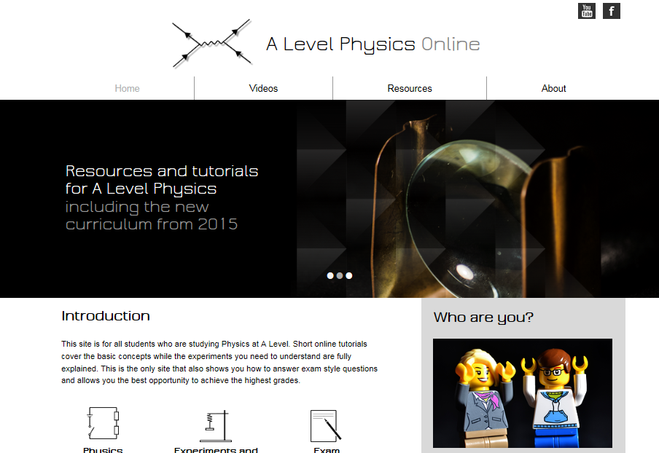
There is also A Level Physics Online made by Mr Matheson that has videos that will eventually cover every single part of the course, including past papers, practical skills and every topic.

